The MS-DOS are the 16-bits programs,and the intel 8086 processor type.The intel 8086 is a 16-bits processor.
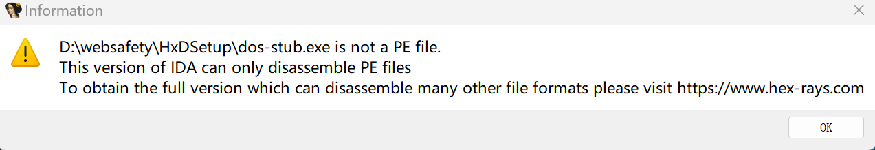
Fuck,what happens!I fallow your steps to create dos-stub.exe but the program throws a error.Maybe only a section of code of the DOS-Stub is not available?

A DOS API! It has already written in the disk
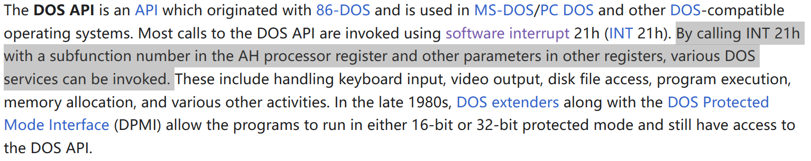
It is included in some registers,the Windows implements the DOS API.DOS is actually the graphical shell.In Windows,DOS can be accessed from a virtual DOS machine.This machine is provided by Windows.
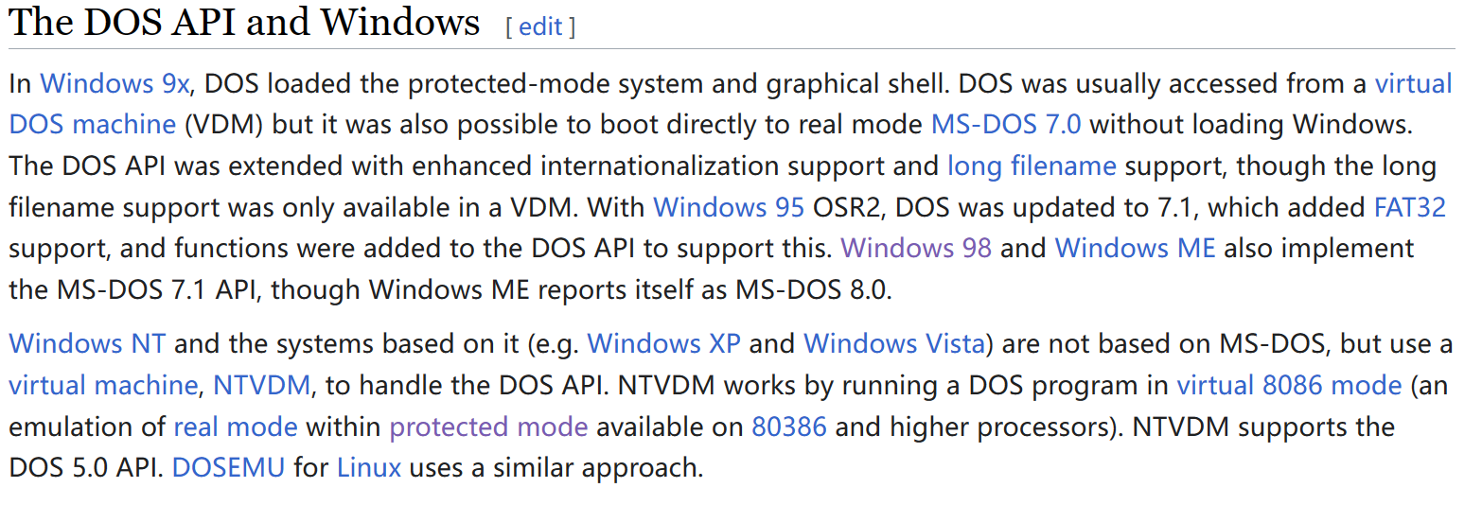
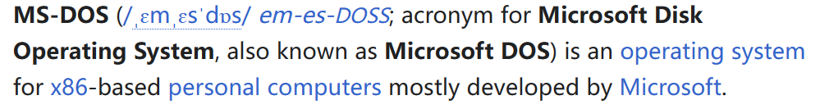
5_17 today’s task is to study the Rich Header
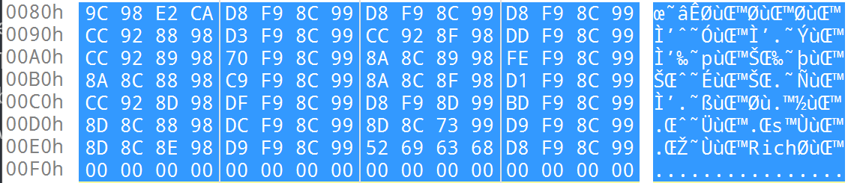
Rich Header is a chunk of data lying between DOS Stub and NT Header.
What is Rich Header?
Rich Header is a chunk of data lying between DOS Stub and NT Header.It is an undocumented structure.It will present only if a executable is built by Microsolft Virtual Stdio toolsets.The structure holds the metadata about the tools used to build the executable like their names,build numbers and so on.
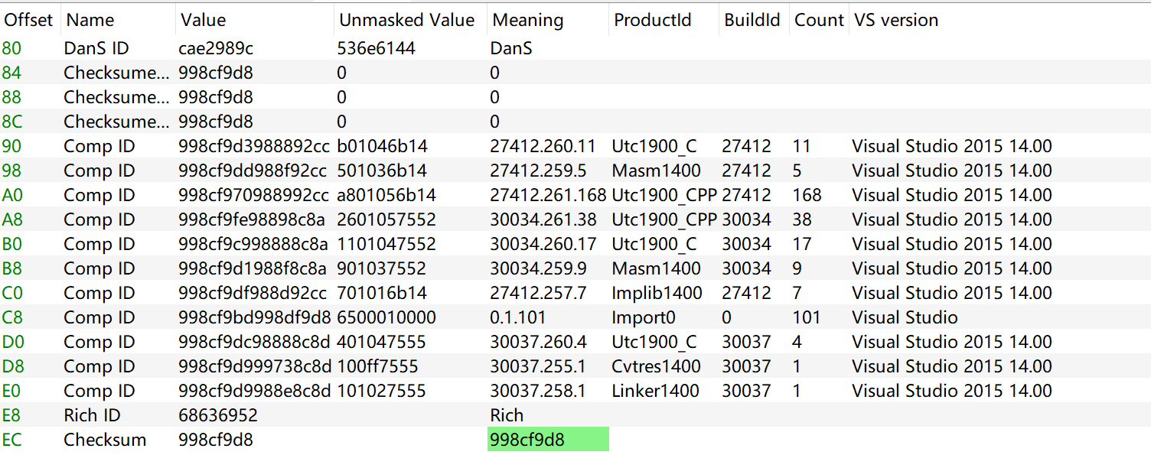
What is its function?
Maybe it can be used to cause confusion by attackers?
Why use “3A72EE9F9” as the key?

I need to write a script to parse the Rich Header.The tools’ ID,build numbers,version and so on.But i don’t know how to use python!!I must study python.

Part3 NT Header
What is NT Header？What is its function？What is its features？What is COFF symbols？How to parse this hexadecimal code?
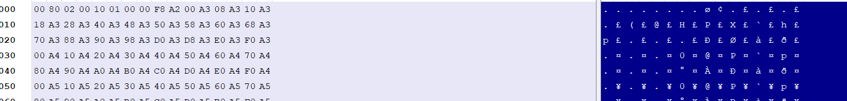
What is the blue part?Absolutely there is a relationship between the left part and the right part.The left part is cleartext passwords,the right part is the result by encrypting.
I must analyse 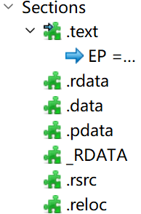all of it.
注意：如果中文更好理解的话写中文，目的是为了学习知识而不是语言。
第一部分要知道RVA是什么，RVA的全称是relative virtual address，中文意思是相对虚拟地址的偏移量。记住，file运行的时候是要放到内存中去的，每一个结构会给一个基地址，我们通过相对于基地址的偏移量来确定结构中的field，每一个地方都存储了特定值，比如果这个文件的特征，属性，文件大小等等。
补充：我现在终于理解了为什么总要用到image这个单词了！因为很多文件使用的时候都要复制到内存中，即通过OS loader 加载到内存中。所以就用了“镜像”这个词。
什么是NT Header呢？
我目前也不知道NT是什么意思
这两个对齐我没怎么理解。
5月19日
Today we will learn about the Data Directory,Section Headers and Sections.
First we need to know what are they?What do the members in their structures indicate?
We need to parse them step by step.
IMAGE_DATA_DIRECTORY DataDirectory[IMAGE_NUMBEROF_DIRECTORY_ENTRIES];
IMAGE_NUMBEROF_DIRECTORY_ENTRIES this value is 16.

So what is Data Directory?It is just a piece of data in one of the sections of the PE file.
Sections are the containers of the actual data of the executable file.They Occupy the rest of the room of PE file,following precisely the Section Headers.

Part5 PE imports
So i want know what is PE imports?What is its structure?
If i want to say about PE imports,I will go over the Import Directory Table,ILT,INT,IAT to understand how the PE file handle the imports.These are some of the Data Directories present in the Import Data Section (.idata).
In my opinion,the information of the imports are included in the Import Data Section(.idata).
So first what is the Import Directory Table. Its structure is defined in winnt.h as IMAGE_IMPORT_DESCRIPTOR The Import Directory Table consists a array of structures,each of them is corresponding a DLL.It doesn’t have the fixed size,so the last directory is null-padded to indicate it is the end of the Import Directory Table.
The structure of the IMAGE_IMPORT_DESCRIPTOR as follows.
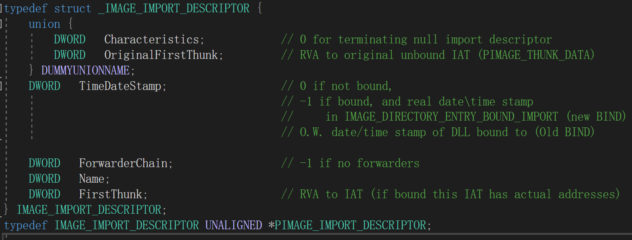

OriginalFirstThunk: the RVA of the ILT(Import Lookup Table)corresponding DLL.just remember it!
TimeDataStamp: 0 if not bound and -1 if bound.In case of an unbound import the time stamp gets updated to the time stamp of the DLL when the image is bound.
In case of a bound import the real time of the DLL can be found in the Bound Import Directory Table in the corresponding IMAGE_BOUND_IMPORT_DESCRIPTOR
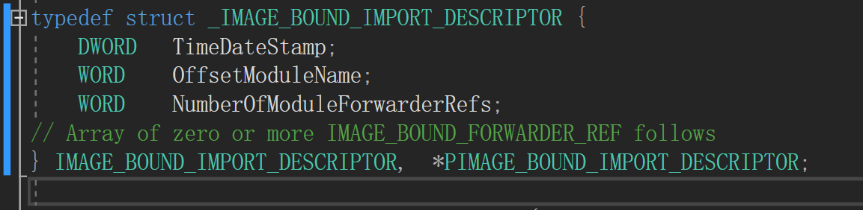

ForwarderChain: The index of the first forwarder chain reference.the forwarder is used to the DLL when the DLL forwards some of its exported function to another DLL.
Name : An RVA of ASCII string contains the the name of the import DLL.
FirstThunk : An RVA of the IAT(Import Address Table).

Bound Imports
Before go over the Bound Imports we need to know what is the Bound Imports.And why we use it?The Bound Imports essentially means that import tables contains the fixed address of the import functions.The fixed address is calculated and written during compile time by linker.

Result the Bound Imports mainly contains the RVA of the ILT,IAT,NameOfDLL and so on.It is mainly about the the information of DLL and imported functions.

Import Lookup Table
Sometimes people refer to it as Import Name Table.
Before we go over it,we need to know what is the Import Lookup Table?What is its features?
*The Import Lookup Table is essentially a table of name or reference,it tells the loader which function is needed from the imported DLL.
The Import Lookup Table consist a array of 32-bit members or 64-bit members and the last bit is set 0 to indicate the end of the structure.

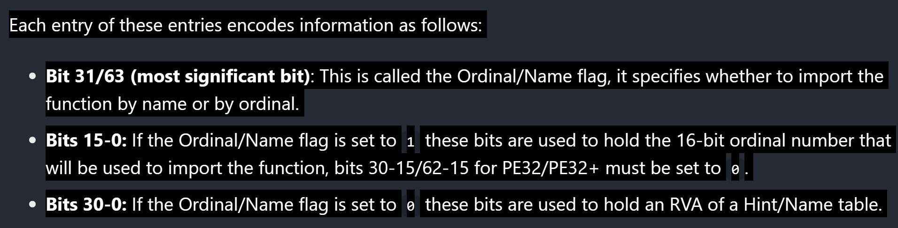
What does it mean?????
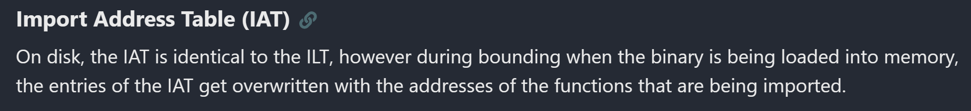

Part6 PE base relocation
What are the relocations are?What are they features?

5月22日
为什么这里的地址是倒着读的？？？
今天写一个parser!!!用c++写

5月23日
太tmd难了！过程，先分析整体框架，然后逐步分析每一步的代码。

Questions：
What is the IMAGE_DIRECTORY_ENTRY_COPYRIGHT ?why is it commented?What does it mean?What is the function of it?
Why define the constant?I tried to find where the constant is used,but failed.By its name,i deduce that it is the size of section of the image file?
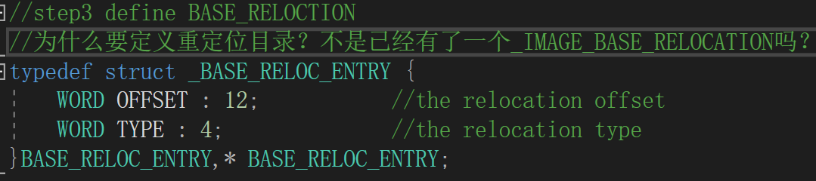
Why the parameters of the function “fopen_s” is the reference of the pointer,not just the pointer?
